**Department of Computer Science and Engineering**

|  |  |
| --- | --- |
| **Course Code:CSE321** | **Credits: 1.5** |
| **Course Name: Operating Systems** | **Semester: Sum’18** |

**Lab 01**

**Basic commands on Linux terminal**

1. **Topic overview:**

Students will be introduced with the Linux operating systems. They will learn basic command of linux terminal. They will solve several problems related to linux command in this lab.

**2. Lesson Fit:** Basic knowledge of windows interaction is required for this lab.

**3. Learning outcome:**

After this lab students will be able to:

* Use linux terminal
* Access file and directories from terminal
* Perform basic operation on the file system of linux,

**4.** **Anticipated Challenges and Possible Solutions :**

Students those are using linux for the first time they will face problem to browse directories from terminal

**Solutions:** Teacher should discuss the linux file system briefly before starting the tasks.

**5.**  **Acceptance and Evaluation**

Students will show their progress as they complete each task. They will be

marked according to their lab performance.

**6. Activity details:**

**First hour:**

**i. Discussion of linux operating system**

Linux is one of popular version of UNIX operating System. It is open source as its source code is freely available. It is free to use. Linux was designed considering UNIX compatibility. Its functionality list is quite similar to that of UNIX.

## **Components of Linux System**

Linux Operating System has primarily three components

* **Kernel** − Kernel is the core part of Linux. It is responsible for all major activities of this operating system. It consists of various modules and it interacts directly with the underlying hardware. Kernel provides the required abstraction to hide low level hardware details to system or application programs.
* **System Library** − System libraries are special functions or programs using which application programs or system utilities accesses Kernel's features. These libraries implement most of the functionalities of the operating system and do not requires kernel module's code access rights.
* **System Utility** − System Utility programs are responsible to do specialized, individual level tasks.

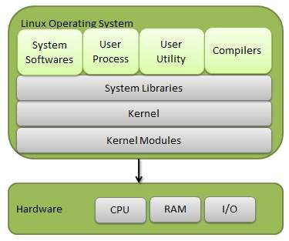

## **Kernel Mode vs User Mode**

Kernel component code executes in a special privileged mode called **kernel mode** with full access to all resources of the computer. This code represents a single process, executes in single address space and do not require any context switch and hence is very efficient and fast. Kernel runs each processes and provides system services to processes, provides protected access to hardware to processes.

Support code which is not required to run in kernel mode is in System Library. User programs and other system programs works in **User Mode** which has no access to system hardware and kernel code. User programs/ utilities use System libraries to access Kernel functions to get system's low level tasks.

## **Basic Features**

Following are some of the important features of Linux Operating System.

* **Portable** − Portability means software can works on different types of hardware in same way. Linux kernel and application programs supports their installation on any kind of hardware platform.
* **Open Source** − Linux source code is freely available and it is community based development project. Multiple teams work in collaboration to enhance the capability of Linux operating system and it is continuously evolving.
* **Multi-User** − Linux is a multiuser system means multiple users can access system resources like memory/ ram/ application programs at same time.
* **Multiprogramming** − Linux is a multiprogramming system means multiple applications can run at same time.
* **Hierarchical File System** − Linux provides a standard file structure in which system files/ user files are arranged.
* **Shell** − Linux provides a special interpreter program which can be used to execute commands of the operating system. It can be used to do various types of operations, call application programs. etc.
* **Security** − Linux provides user security using authentication features like password protection/ controlled access to specific files/ encryption of data.

## **Architecture**

The following illustration shows the architecture of a Linux system −

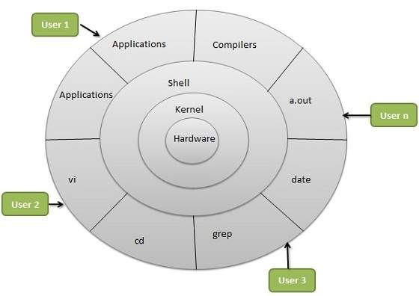

The architecture of a Linux System consists of the following layers −

* **Hardware layer** − Hardware consists of all peripheral devices RAM/HDD/CPUetcRAM/HDD/CPUetc.
* **Kernel** − It is the core component of Operating System, interacts directly with hardware, provides low level services to upper layer components.
* **Shell** − An interface to kernel, hiding complexity of kernel's functions from users. The shell takes commands from the user and executes kernel's functions.
* **Utilities** − Utility programs that provide the user most of the functionalities of an operating systems.

**ii.Discussion on file system of Linux**

A file is a named collection of related information that is recorded on secondary storage such as magnetic disks, magnetic tapes and optical disks. In general, a file is a sequence of bits, bytes, lines or records whose meaning is defined by the files creator and user.

**File Structure:**

* A File Structure should be according to a required format that the operating system can understand.
* A file has a certain defined structure according to its type.
* A text file is a sequence of characters organized into lines.
* A source file is a sequence of procedures and functions.
* An object file is a sequence of bytes organized into blocks that are understandable by the machine.
* When operating system defines different file structures, it also contains the code to support these file structure. Unix, MS-DOS support minimum number of file structure.

**File Type**  
File type refers to the ability of the operating system to distinguish different types of file such as text files source files and binary files etc. Many operating systems support many types of files. Operating system like MS-DOS and UNIX have the following types of files −  
  
**Ordinary files:**

* These are the files that contain user information.
* These may have text, databases or executable program.
* The user can apply various operations on such files like add, modify, delete or even remove the entire file.Directory files
* These files contain list of file names and other information related to these files.

**Special files**

* These files are also known as device files.
* These files represent physical device like disks, terminals, printers, networks, tape drive etc.  
  **These files are of two types −**  
    
  **Character special files** − data is handled character by character as in case of terminals or printers.  
    
  **Block special files** − data is handled in blocks as in the case of disks and tapes.

**Second hour:**

**i. Practise basic commands from terminal.**

**1. pwd —** When you first open the terminal, you are in the home directory of your user. To know which directory you are in, you can use the “pwd”command. It gives us the absolute path, which means the path that starts from the root. The root is the base of the Linux file system. It is denoted by a forward slash( / )ezgif.com-webp-to-png.png. The user directory is usually something like "/home/username".

**2. ls —** Use the "Is" command to know what files are in the directory you are in. You can see all the hidden files by using the command “ls -a”.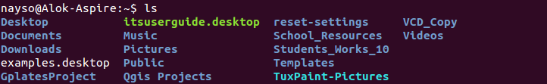

**3. cd —** Use the "cd" command to go to a directory. For example, if you are in the home folder, and you want to go to the downloads folder, then you can type in “cd Downloads”. Remember, this command is case sensitive, and you have to type in the name of the folder exactly as it is. But there is a problem with these commands. Imagine you have a folder named “Raspberry Pi”. In this case, when you type in “cd Raspberry Pi”, the shell will take the second argument of the command as a different one, so you will get an error saying that the directory does not exist. Here, you can use a backward slash. That is, you can use “cd Raspberry\ Pi” in this case. Spaces are denoted like this: If you just type “cd” and press enter, it takes you to the home directory. To go back from a folder to the folder before that, you can type “cd ..” . The two dots represent back.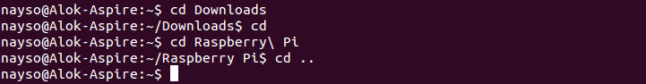

4. mkdir & rmdir — Use the mkdir command when you need to create a folder or a directory. For example, if you want to make a directory called “DIY”, then you can type “mkdir DIY”. Remember, as told before, if you want to create a directory named “DIY Hacking”, then you can type “mkdir DIY\ Hacking”. Use rmdir to delete a directory. But rmdir can only be used to delete an empty directory. To delete a directory containing files, use rm.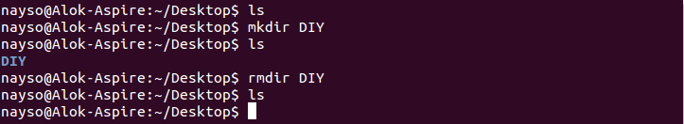

**5. rm -** 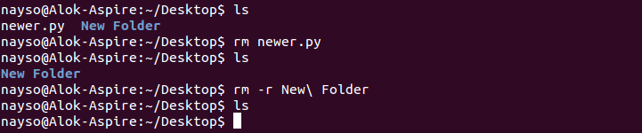

**6. touch — The touch command is used to create a file. It can be anything, from an empty txt file to an empty zip file. For example, “touch new.txt”.**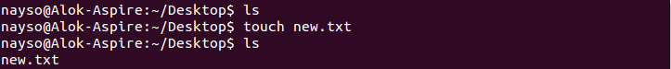

**7. man & --help —** To know more about a command and how to use it, use the man command. It shows the manual pages of the command. For example, “man cd” shows the manual pages of the cd command. Typing in the command name and the argument helps it show which ways the command can be used (e.g., cd –help).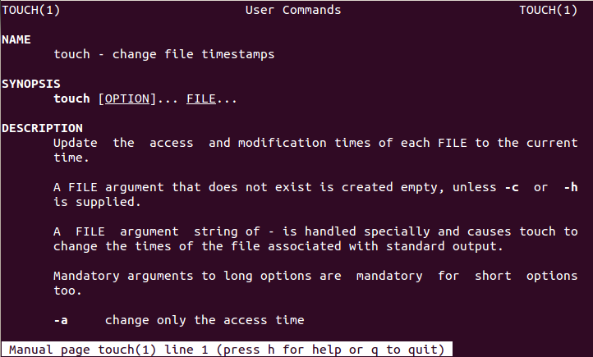

**8. cp —** Use the cp command to copy files through the command line. It takes two arguments: The first is the location of the file to be copied, the second is where to copy.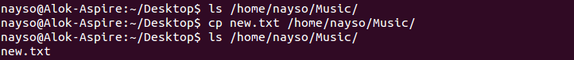

**9. mv —** Use the mv command to move files through the command line. We can also use the mv command to rename a file. For example, if we want to rename the file “text” to “new”, we can use “mv text new”. It takes the two arguments, just like the cp command.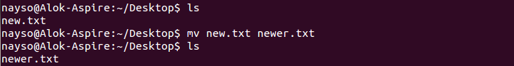

**10. locate —** The locate command is used to locate a file in a Linux system, just like the search command in Windows. This command is useful when you don't know where a file is saved or the actual name of the file. Using the -i argument with the command helps to ignore the case (it doesn't matter if it is uppercase or lowercase). So, if you want a file that has the word “hello”, it gives the list of all the files in your Linux system containing the word "hello" when you type in “locate -i hello”. If you remember two words, you can separate them using an asterisk (*). For example, to locate a file containing the words "hello" and "this", you can use the command “locate -i *hello*this”.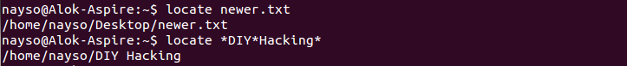

**Third hour:** Problem solving (Lab tasks)

**Lab tasks**

**Task 1:** open terminal and navigate to Desktop**.**

**Task 2:** Enter command **ls -l** in terminal and explain the output.

**Task 3:** Create a file name.txt in Desktop

**Task 4:** change the permission of the file to owner: read write, execute, group: read and execute and for other user execute only.

**Task 5:** create a directory named mydirectory

**Task 6:** copy the file name.txt to mydirectory.

**Task 7:**  Delete the file name.txt from desktop